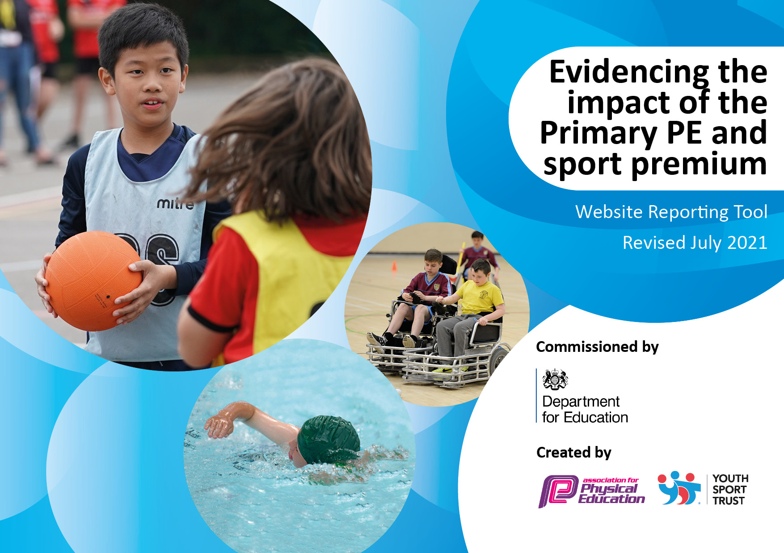
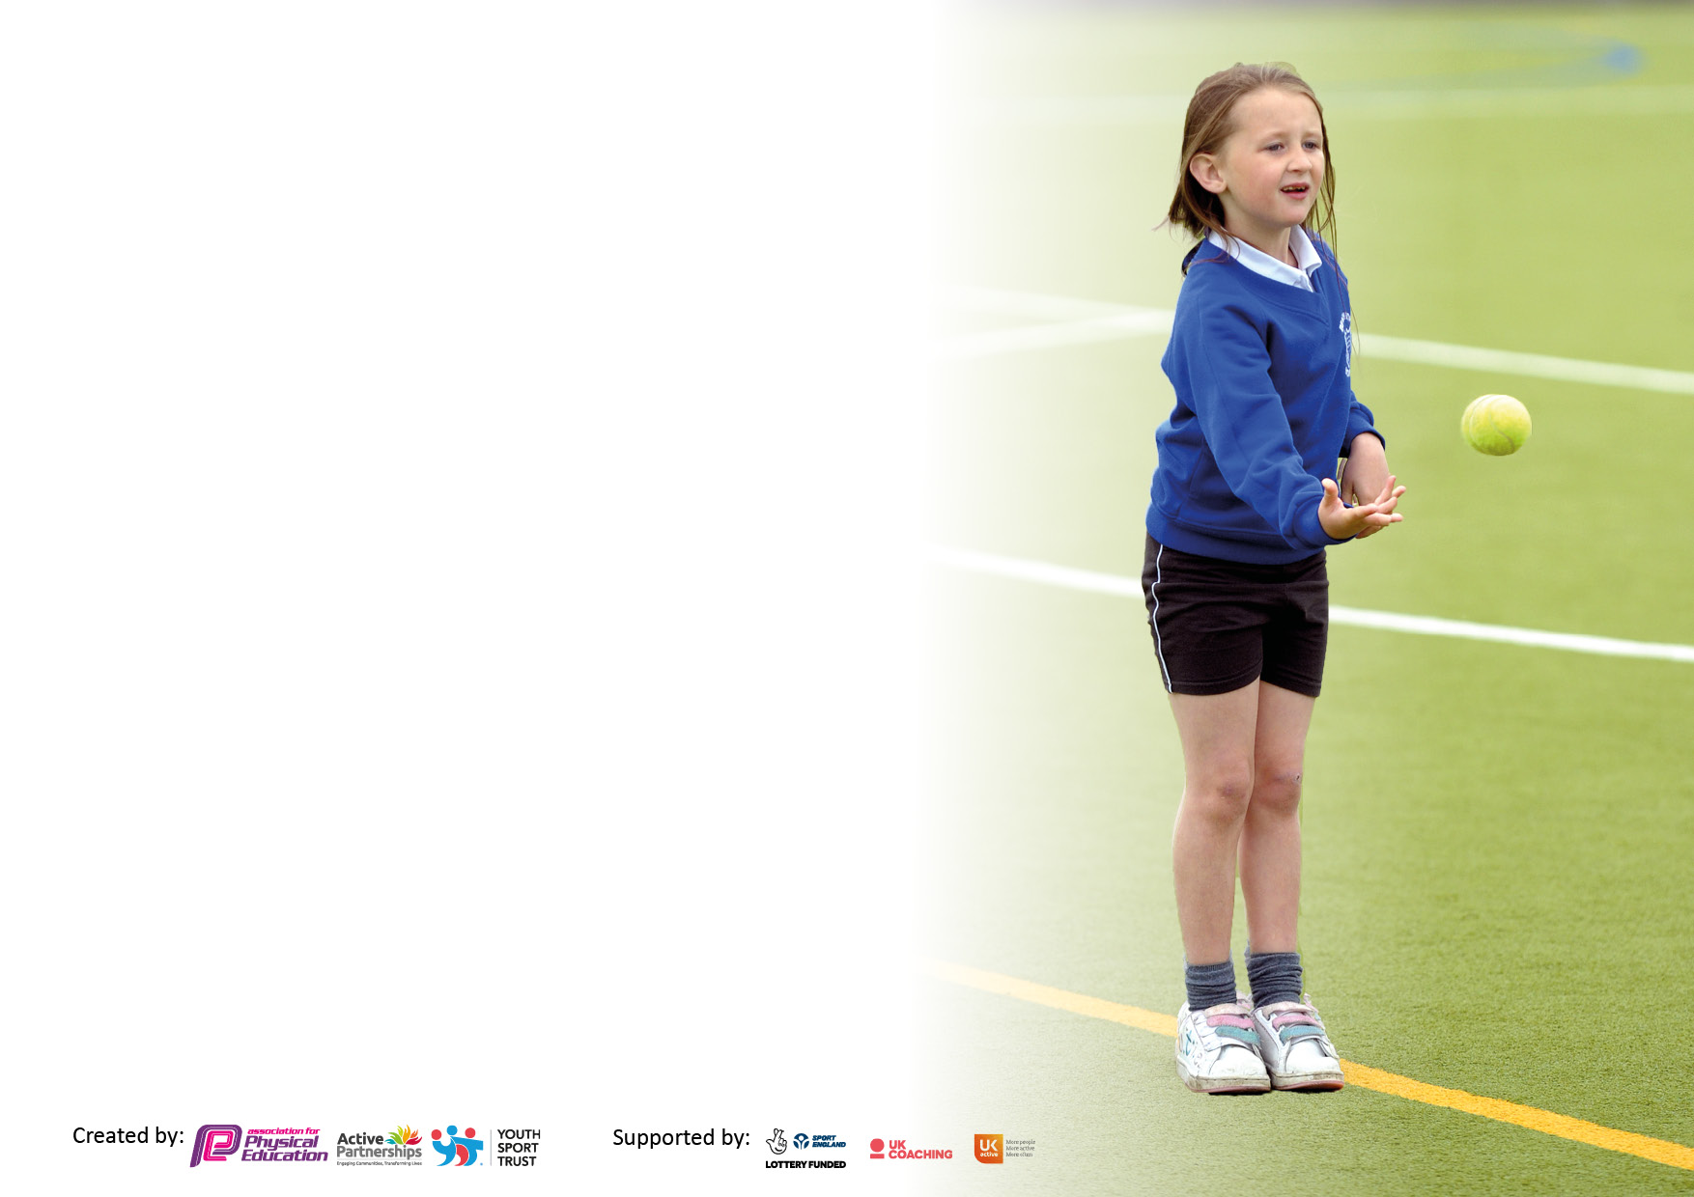

It is important that your grant is used effectively and based on school need. The Education Inspection Framework makes clear there will be a focus on ‘whether leaders and those responsible for governors all understand their respective roles and perform these in a way that enhances the effectiveness of the school’.

Under the Quality of Education Ofsted inspectors consider:
Intent - Curriculum design, coverage and appropriateness
Implementation - Curriculum delivery, Teaching (pedagogy) and Assessment
Impact - Attainment and progress

To assist schools with common transferable language this template has been developed to utilise the same three headings which should make your plans easily transferable between working documents.

Schools must use the funding to make additional and sustainable improvements to the quality of Physical Education, School Sport and Physical Activity (PESSPA) they offer. This means that you should use the Primary PE and sport premium to:

- Develop or add to the PESSPA activities that your school already offer
- Build capacity and capability within the school to ensure that improvements made now will benefit pupils joining the school in future years
- The Primary PE and sport premium should not be used to fund capital spend projects; the school’s budget should fund these.

Pleasevisitgov.ukfortherevisedDfEguidanceincludingthe5keyindicatorsacrosswhichschoolsshoulddemonstrate animprovement.Thisdocumentwillhelpyoutoreviewyourprovisionandtoreportyourspend.DfEencouragesschools to use this template as an effective way of meeting the reporting requirements of the Primary PE and sport premium.

We recommend you start by reflecting on the impact of current provision and reviewing the previous spend.

Schools are required to publish details of how they spend this funding, including any under-spend from 2019/2020, as well as on the impact it has on pupils’ PE and sport participation and attainment. All funding must be spent by 31st July 2022.

We recommend regularly updating the table and publishing it on your website throughout the year. This evidences your ongoing self-evaluation of how you are using the funding to secure maximum, sustainable impact. Final copy must be posted on your website by the end of the academic year and no later than the 31st July 2021. To see an example of how to complete the table please click HERE.

Details with regard to funding
Please complete the table below.

Total amount carried over from 2021/22 | £
Total amount allocated for 2022/23 | £14865
Total amount of funding for 2022/23. To be spent and reported on by 31st July 2023. | £14865
Swimming Data
Please report on your Swimming Data below.

Meeting national curriculum requirements for swimming and water safety.

N.B. Complete this section to your best ability. For example you might have practised safe self-rescue techniques on dry land which you can then transfer to the pool when school swimming restarts.
Due to exceptional circumstances priority should be given to ensuring that pupils can perform safe self rescue even if they do not fully meet the first two requirements of the NC programme of study
What percentage of your current Year 6 cohort swim competently, confidently and proficiently over a distance of at least 25 metres?  N.B. Even though your pupils may swim in another year please report on their attainment on leaving primary school at the end of the summer term 2020.  Please see note above | 57%
What percentage of your current Year 6 cohort use a range of strokes effectively [for example, front crawl, backstroke and breaststroke]?  Please see note above | 59%
What percentage of your current Year 6 cohort perform safe self-rescue in different water-based situations? | 58%
Schools can choose to use the Primary PE and sport premium to provide additional provision for swimming but this must be for activity over and above the national curriculum requirements. Have you used it in this way? | Yes/No

Action Plan and Budget Tracking
Capture your intended annual spend against the 5 key indicators. Clarify the success criteria and evidence of impact that you intend to measure to evaluate for pupils today and for the future.

Academic Year: 2022/23 | Total fund allocated: 14865 | Date Updated: 16/7/23
Key indicator 1: The engagement of all pupils in regular physical activity – Chief Medical Officers guidelines recommend that primary school pupils undertake at least 30 minutes of physical activity a day in school |  |  |  | Percentage of total allocation:
 |  |  |  | 30%
Intent | Implementation |  | Impact
Your school focus should be clear what you want the pupils to know and be able to do and about  what they need to learn and to  consolidate through practice: | Make sure your actions to achieve are linked to your intentions: | Funding allocated: | Evidence of impact: what do pupils now know and what can they now do? What has changed? | Sustainability and suggested next steps:
Working towards at least 30 minutes of physical activity for all scholars through further engagement in the School Games Mark Outcomes.  Love Life Sports Coaching Years 2-6  Continued work with Bruce Dyer, pupils attitudes to sport and self-esteem continue to improve. | PE Lead assessment of scholars’ activity levels throughout the school day using the Active School Planner Heatmap tool.  PE Lead accessing high quality training and signposting in a range of initiatives to promote and facilitate physical activity throughout the school day.  Half termly lesson packages for all pupils in school, children to access a series of lessons across the school year. | £4631 | An increase in physical abilities and fitness levels, teamwork, positive interactions between children in classes during lessons and also unstructured times such as playtimes and groups unsupported at lunch. Behaviour incidents have lowered.  Times of inactivity identified, least active children also identified including children requiring behaviour support. Pupil voice collected regarding which lunch time activities they would like to take part in. | New resources purchased on an as and when basis to replenish playtime equipment to ensure play times for all are of high quality and provide high quality experiences of physical and mental wellbeing games at both structured and unstructured play times.  The least active children and children requiring the most support with behavioural issues with increasing their physical activity and we will see a decline in unwanted behaviour.
Key indicator 2: The profile of PESSPA being raised across the school as a tool for whole school improvement |  |  |  | Percentage of total allocation:
 |  |  |  | 22%
Intent | Implementation |  | Impact
Your school focus should be clear what you want the pupils to know and be able to do and about  what they need to learn and to  consolidate through practice: | Make sure your actions to achieve are linked to your intentions: | Funding allocated: | Evidence of impact: what do pupils now know and what can they now do? What has changed? | Sustainability and suggested next steps:
The Astrea Promise Physical Literacy Strategy is a project across all Astrea Primary Academies. It is a commitment to our scholars that they will benefit from high standards of PE, School Sport, and Physical Activity (PESSPA) at all levels of their school experience in order to thrive and lead active, healthy, physically literate lives.  A transparent and accurate account of spending on this document will enable parents and governors to see progress against the KPIs and challenge where necessary.  Scholars experience a consistent and rounded approach to PESSPA that is measured against a national standard such as the School Games Mark.  Communication to staff, parents, governors, scholars, and prospective scholars that PESSPA is very much a part of Astrea school life.  Recognition and celebration of sporting achievements at Trust level to further raise the profile of PESSPA as an important part of Astrea life and something Astrea scholars can excel at.  After-school clubs – Covid compliant- DanceMania x2 Bruce Dyer x1 | The programme of work covers 10 key areas which will result in improvements in all 5 PE and Sport Premium KPIs. See each KPI for a breakdown of the work.  School accesses ongoing 1-1 support for the Programme where needed.  School accesses Trust support on evaluating effective PE and Sport Premium spending and preparation of related documents.  School accesses Trust support on working towards the standards needed to achieve School Games Mark Status of silver or above including submitting the application.  School promotes PE and sport through visibility of their PE and Sport Premium reporting on their website and School Games Mark Award in school.  Nominate scholars and staff for Astrea Promise Physical Literacy Awards and attend the Astrea Promise Physical Literacy Awards Evening on 6th July.  A wide-range of after-school activities are provided to suit all ages and abilities. | £ 3,708  20% of overall  grant allocation  £3570 | Our school has met the targets of the 10 Key Performance Indicators across this year  High quality impact statement based on a well-planned PESSPA offer with real intent and measurable progress  School maintaining the Silver School Games Mark  Impact report signed by governors and shared with external parties where relevant  All teachers nominating children from a range of areas including sports girl of the year, team of the year etc. A good attendance by school staff, pupils, parents and central team.  Promotes active lifecycle and provides opportunities for children to develop physical abilities and confidence in a range of sports. Simulate interest of children less likely to engage in sporting activities through use of different types of sports.  Develop extra-curricular provision of PE and sport. | All children from nursey to Year 6 to have a positive relationship with physical activity through the unique and child centred approach of Real PE.  Continue to liase with after school club providers and increase the number of clubs that are offered.

Key indicator 3: Increased confidence, knowledge, and skills of all staff in teaching PE and sport |  |  |  | Percentage of total allocation:
 |  |  |  | 4%
Intent | Implementation |  | Impact
Your school focus should be clear | Make sure your actions to | Funding | Evidence of impact: what do | Sustainability and suggested
what you want the pupils to know | achieve are linked to your | allocated: | pupils now know and what | next steps:
and be able to do and about | intentions: |  | can they now do? What has
what they need to learn and to |  |  | changed?
consolidate through practice:
High-quality PE lessons, pedagogy, and curriculum so that all scholars make progress in physical literacy including skill acquisition, game play and PE theory.  To attend all Astrea Active PE Conferences each term for CPD and networking for clubs, trips, competitions and SGO support  Continued use of Real PE to ensure high-quality Multi-Ability PE lessons in line with current curriculum requirements. Real Foundations introduction- specialised Early Years PE programme from Real PE  Continue with use of Real PE to ensure high quality Multi-Ability PE lessons in line with current curriculum requirements. Real foundations introduction- Nursery specialised EY Programme from Real PE | Subject lead to attend 3 Astrea Promise PE conferences for continuing professional development in the role including take aways to disseminate to the whole school. Creation of a strong network between Hub schools and all primary schools across the Trust.  Trust support for PE lead to carry out their role. Assessment against subject lead role and the programme’s 10 KPIs to be included in PE Lead’s appraisal.  Curriculum and PE assessment development.  -Subject leads to ensure all staff have access to the Jasmine online learning platform  -Subject leads to equip staff with the learning nutrition poster and parts of the Jasmine learning that aid a quality first teaching session  -Subject leads to use knowledge and CPD gained at the conferences to develop opportunities for teaching and learning, assessment, clubs and competitions  -Release time 1 per month for subject lead | £495 | Attendance of the PE lead at the conferences, observed difference in the quality of teaching in PE throughout the school.  Equip children with high-quality PE equipment for their lessons; Purchased in July  Good or better PE lessons across school; Curriculum continues to be fully resourced and audited as well as replenished as needed. PE to be verbalized about and evident in and around school.  Classes to access one lesson per week of high quality indoor PE alongside Real PE- child centred approach Physical Education | Staff voice to be completed around strengths and feelings towards Real PE and the general teaching of PE.  Regular audits of equipment.  Knowledge and experience gained transferred year upon year
Key indicator 4: Broader experience of a range of sports and activities offered to all pupils |  |  |  | Percentage of total allocation:
 |  |  |  | 40%
Intent | Implementation |  | Impact
Your school focus should be clear | Make sure your actions to | Funding | Evidence of impact: what do | Sustainability and suggested
what you want the pupils to know | achieve are linked to your | allocated: | pupils now know and what | next steps:
and be able to do and about | intentions: |  | can they now do? What has
what they need to learn and to |  |  | changed?
consolidate through practice:
All scholars have the confidence and opportunity to access extra-curricular physical activities improving the probability that sport and physical activity will be a part of their life in the future, this includes swimming.  Scholars have the opportunity to excel in sport.  To provide children with a variety of sports clubs and the opportunity to take part in competitions and beyond | Working towards all scholars accessing at least one extra-curricular club, at least one personal challenge and at least one off-site competitive experience. Club and competition data collection and analysis to provide baseline figures to assess the effectiveness of current provision and identify gaps. Trust support on closing the gaps to meet the target.  Facilitation of links with School Games competitions and experiences, high level competition within the Trust, Ambassador Programme resources and support to make links with clubs and sporting professionals from a range of sporting careers.  Staff to run some physical activity clubs | £5460 | A slight increase in attendance compared to 2021/22.  Ongoing relationship with at least one ambassador (Bruce Dyer) board and taster sessions sometimes offered and an increase in the number of scholars involved in clubs outside school.  Developing children’s confidence and self esteem through trying a range of outdoor sporting activities. Develop the principles taught in lessons such as respect. | Children showing an increase in confidence and targeted groups of children engaging in more physical activity. Behavioural issues declining and children showing more resilience and positivity.  Continue professional relationships with professionals involved with Highgate and continue to seek further opportunities of Elite sports person involvement etc.

Key indicator 5: Increased participation in competitive sport |  |  |  | Percentage of total allocation:
 |  |  |  | 4%
Intent | Implementation |  | Impact
Your school focus should be clear | Make sure your actions to | Funding | Evidence of impact: what do | Sustainability and suggested
what you want the pupils to know | achieve are linked to your | allocated: | pupils now know and what | next steps:
and be able to do and about | intentions: |  | can they now do? What has
what they need to learn and to |  |  | changed?
consolidate through practice:
All scholars experience competition, in a positive and empowering environment, with the best of the best battling it out for Astrea Promise trophies and trust-wide glory.  Targeted group of Scholars have a positive competition experience.  To provide the opportunity for intra and inter house competition and also at Trust wide level | Access to 3 Trust elite pathway competitions which build from intra-school to inter-school and finally inter-hub to create an Astrea Champion. Sports to include Cross Country, Netball and Olympics themed multi-skills. Includes organisation of equipment, transport, certificates, medals and trophies, volunteers, and venues.  Access to Tri-Golf Participation Tournament including organisation of equipment, transport, certificates, volunteers, and venue.  Subject lead to co-ordinate competitions with other schools in the HUB | £721 | 100% positive responses from Pupil Voice taken after the tournament, children interested in going to another competition or getting involved with a club. | Continue to provide transport to and from any event scheduled.  Continue to take part in Hub Inter House tournaments in 23/24  PE lead to continue to monitor the participation of PP, SEN, FSM groups regarding competitive sporting events ensuring fair access for all groups  Termly basis of liaising with other PE leads across the trust.

Signed off by
Head Teacher:
Date:
Subject Leader: | N. Hewitt
Date: | 29.6.23
Governor:
Date:

