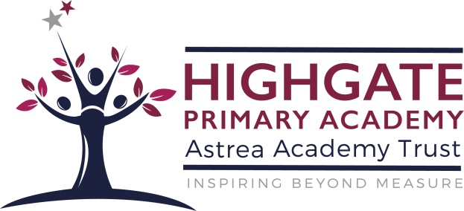

SEND POLICY
Revised: September 2022
Review Date: September 2023

Special Educational Needs Information Report

At Highgate Primary Academy we are committed to ensuring that every child gets the best support we can offer in order to help them reach their full potential. This includes feeling confident and happy within school and making the best progress possible.

Every child is an individual and has individual needs that will affect their learning. Sometimes children need special support to give them a helping hand in order to catch up with the other children of the same age. They may need this support for a short time or a longer period, but during this time they will be part of our Special Educational Needs (SEN) Register and we will monitor their progress, look carefully at what special support they need and keep in close touch with their parents.

Our Special Educational Needs and Disability Co-ordinator is Mrs S. Sankey who coordinates a team of people to provide additional support to our more vulnerable pupils.

What is SEND?

SEND means ‘Special Educational Need and Disability’
Children learn at different rates. Many pupils, at some time during their academy career, will experience difficulties which may impact upon their rate of learning; these may be long or short term.
A child or young person has SEN if they have a learning difficulty or disability which calls for special educational provision to be made for them. A child of compulsory school age or a young person has a learning difficulty or disability if they:

have a significantly greater difficulty in learning than the majority of others of the same age;

- have a disability which prevents or hinders them from making use of educational facilities of a kind generally provided for others of the same age

Children with SEND have needs that fall into a range of categories. The categories of SEND that provision is made for in our academy are:

Moderate Learning Difficulties (MLD)
- Specific Learning Difficulties (SLD)
- Autistic Spectrum Disorder (ASD)
- Social, Emotional and Mental Health (SEMH)
- Visual Impairment (VI)
- Hearing Impairment (HI)
- Physical Difficulties (PD)
- Speech, Language and Communication Need (SLCN)
- Multi-sensory Impairment (MSI)

What is a disability?

The Equality Act 2010 states that a person has a disability if they have a physical or mental impairment and the impairment has a substantial and long-term adverse effect on their ability to carry out normal day-to-day activities.

A physical or mental impairment includes: learning difficulties including specific learning difficulties; medical conditions including epilepsy, diabetes, more severe forms of asthma and eczema; autism; speech, language and communication impairments.

If the impairment has a substantial and long-term effect on a person’s ability to carry out normal day-to- day activities it may amount to a disability.

What should I do if I think my child has special needs or a disability?

If you feel that your child may have SEND then you should ask to speak to your child's class teacher. Your child's class teacher may also feel that it would be helpful to have the SENDCo attend the meeting. The academy closely monitors all children. If the attainment of your child is below the range expected we will put in place some additional support to help remove barriers to learning. Your child will be placed on the SEN register. This will enable us to monitor your child and their progress more quickly.

Admission Arrangements for pupils with SEND
Highgate Primary Academy follows the admission protocols outlined in the School Admission Code, 2014 for all pupils including those with SEND.

https://www.gov.uk/government/uploads/system/uploads/attachment_data/file/389388/School_Admissi ons_Code_2014_-_19_Dec.pdf

We strive to be an inclusive academy. Therefore, no pupils will be refused admission to the academy on the basis of his or her special educational need. Highgate Primary Academy works in line with the SEN and Disability Act, we will not discriminate against disabled children and we will take reasonable steps to provide effective educational provision. The year prior to transfer, the SENDco will visit and make contact with the previous school. This is to ensure they can assess the provision needs for each child and in some cases, additional visits are arranged if this is appropriate. The SENDco will, if possible, attend the Annual Review of EHCP or Statement to discuss the appropriate provision for pupils prior to transfer to Highgate Primary Academy.

The local authority must make it clear in their arrangements which pupils have Statements or Education Health Care Plans, these will be admitted following the Local Authority Policy and ensuring the school can meet their needs under the new Code of Practice.

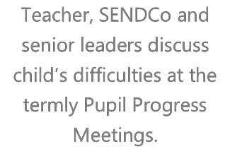
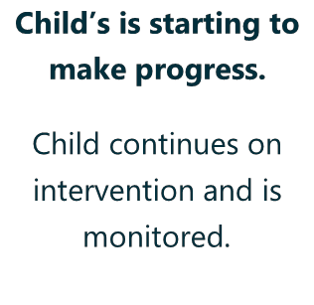
What happens if my child has difficulties with learning?
Teacher, SENDCo and senior leaders discuss child’s difficulties at the termly Pupil Progress Meetings.
Child’s is starting to make progress.
Child continues on intervention and is monitored.

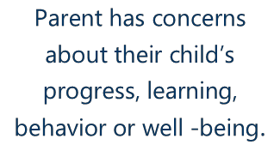
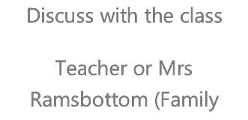
The flow diagram below shows what happens if parents or teachers have concerns about their child’s progress or learning.
Parent has concerns about their child’s progress, learning,
behavior or well -being.
Discuss with the class
Teacher or Mrs Rogers (FLO)

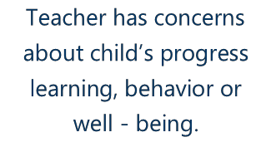
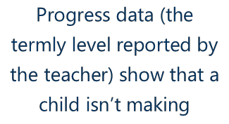
Teacher has concerns about child’s progress learning, behavior or well - being.
Progress data (the termly level reported by the teacher) show that a child isn’t making

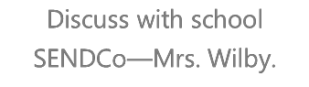
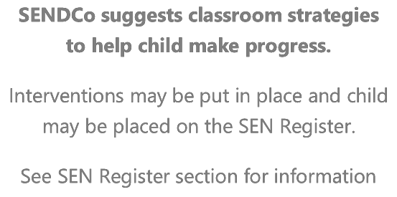
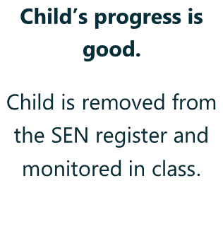
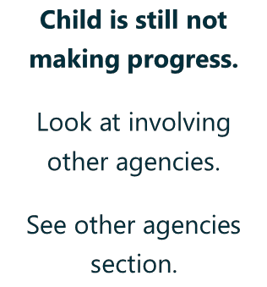
Discuss with school
SENDCo—Mrs.Sankey
SENDCo suggests classroom strategies to help child make progress.
Interventions may be put in place and child may be placed on the SEN Register.
See SEN Register section for information
Child’s progress is reviewed regularly by teachers and SENDCo and
discussed with parents
Child’s progress is good.
Child is removed from
the SEN register and
monitored in class.
Child is still not making progress.
Look at involving
other agencies.
See other agencies
section.

How is extra support allocated to children with additional needs?

For many children, simple changes to the way that the curriculum is delivered can make a significant impact on removing the barriers to their learning. These changes accelerate learning and help children to catch up with their peers and make expected levels of progress. This is called ‘differentiating the curriculum'. Your child's class teacher will be doing this on a daily basis in order to ensure that all the children in the class can make the most of the learning experiences presented.

For some children this may not be enough to help them make adequate progress and they may need something which is 'additional to and different from' that which is normally provided for all children. If a child requires this type of support the academy will monitor them according to the SEN Code of Practice. You will be kept informed of the additional support that your child is receiving. This could mean that the class teacher may be using different strategies to help your child to learn, or perhaps your child will be receiving some additional support in a small group alongside other children with similar needs. The small group work will be carefully targeted to address your child's needs and his/her progress will be closely monitored and evaluated.

The academy will provide some suggestions as to how you can best support your child's learning at home. The important thing is give lots of praise and encouragement and to try and make the learning fun.

You will be kept informed of their progress through regular meetings. At the meeting the academy will share with you how they plan to personalise learning for your child.

Highgate Primary Academy believes in an inclusive environment for all pupils and takes many steps to prevent pupils with SEND being treated less favourable than other pupils. The table below outlines how we promote this:

Eliminate unlawful discrimination,  harassment and victimisation | Equality of opportunity | Create good relations
- Policies to follow: SEN, Anti bullying, Behavior  - Accessibility Plan  - Continual Professional Development for all staff which includes differentiation, reasonable adjustments, equality of access, teaching and learning and safeguarding.  - Incidents log which are kept and monitored in school by the Senior Leadership Team.  - Senior Management Meetings take place focusing on day-day management and development plans.  - Liaison with governors which informs and updates areas of the School Improvement Plan. | - Analysis of attainment data at each progress check point by teachers and Senior Leadership Team.  - Analysis is shared and actions are set.  - Exam adjustments are organized.  - Supporting aids included as necessary.  - PHSE and assembly content are regularly adapted and updated to reflect current and topical issues.  - Regular lesson observations by Senior Management Team to ensure accessibility and progress against Ofsted standards.  - 1pps and provision maps are kept and updated regularly to ensure all staff are aware of relevant barriers to learning and support pupils further as necessary.  - Where necessary the SENDco will coordinate external outside agencies for individuals: Speech and Language Therapy,  Educational Psychology,  Occupational Therapy, Behavior Support, School Nurse, CAMHS, Team around the Child and Children in Need in conjunction with Safeguarding Lead. | - Transition program throughout each year including visits for new starters and FS staff visiting nursery settings.  - PHSE and assembly content are regularly adapted and updated to reflect current and topical issues.  - Pupils are aware of key members of staff they can talk to who will listen to any concerns and act upon them if necessary.

What interventions does the academy deliver, and how could they
support my child’s progress?

Some children may require interventions of a one to one or small group nature for short periods of time. These are overseen by the class teacher and progress is carefully monitored. The SENDCo and Head of Academy are responsible for the allocation of one to one and group interventions support timetable for the School.

What is an EHA?

An EHA is an Early Help Assessment. It begins with a gathering of information. Once established, the EHA will help the academy to organise a Team Around the Child Meeting (TAC), this involves everyone involved considering the best way in which your child can be supported. For the majority of children, actions taken using this graduated approach often mean that the child begins to make adequate or expected levels of progress. If this is the case, the academy may decide that your child no longer needs additional support because they are making the appropriate progress.

What is a statutory assessment?

A small percentage of children require support of an additional nature beyond this. If this is the case, then the SENDCo may discuss with you the possibility of asking the Local Authority to undertake a statutory assessment of your child's needs. If this is considered appropriate, then the school will collect together all your child's information and evidence of all the carefully evaluated additional strategies and interventions that have been put place and with your permission send it off to the Local Authority for them to consider the information at a panel meeting and make a decision whether or not to carry out a statutory assessment of your child's needs. Whilst this is taking place the academy will continue to meet your child's needs with the support that is already in place.

Once the Local Authority receives a request to consider whether to make a statutory assessment or not, a legal timescale begins. The process of statutory assessment is carefully bound by the legislation and guidance within the SEN Code of Practice. The SENDCo will be able to explain the process and timescales to you or alternatively you would find this in the SEN Code of Practice. www.gov.uk/government/.../send-code-of-practice-0-to-25

If the decision is made to go ahead with a statutory assessment then the Local Authority will signpost you to guidance and support that will assist you through the process. The Parent Partnership Service is an independent organisation that work with parents/carers and other agencies, to ensure children and young people with SEND are helped in the right way. They can be contacted on: parentpartners@barnsley.gov.uk

How will my child's learning needs be assessed and their progress monitored?

The academy has a rigorous program for the monitoring and assessment of children’s learning. On- going assessments take place on a daily basis to ensure that the learning opportunities presented to children are appropriate to meet their needs and aid their learning and development. Some assessment takes place at the end of specific pieces of work to inform teacher's planning of the children's next steps in learning.

The academy sets aspirational targets for all its children including those with special educational needs. Individual targets are shared with children so that they are aware of what they need to learn next. Children with special educational needs have a one page profile (1pp) this sets out targets that are specific to your child’s needs. Plans are shared with parents and their contribution to the setting of new targets is welcomed. Once a new 1PP has been written the academy will carefully monitor the progress being made.

How is Highgate Academy accessible to children with SEND?

There are a wide range of ways in which the academy makes adjustments for children and adults with additional needs or impairments e.g.

Visual cues are clearly displayed in classroom and communal areas in order to facilitate easier access for our children who require a communication friendly environment. Visual timetables are clearly displayed in all classrooms.
- The academy promotes a dyslexia friendly environment and a wide range of dyslexia friendly strategies are evident in all classrooms.
- The academy will always endeavor to make reasonable adjustments to internal and external teaching and learning environments to best accommodate the additional needs to pupils.

Highgate Primary Academy strives to ensure access is provided for all pupils is provided. Details below outline how adjustments are made to ensure children with SEND can access provision.

Staff CPD on all areas of SEN
- Advice from outside agencies including Educational Psychologist and Speech and Language Therapy is implemented and objectives for Education Health Care Plans and Statements are planned for and implemented.
- Accessibility Plan which includes doors that can be accessed by wheel chair.
- Specially trained teaching assistants to deliver programs to support pupils with additional needs such as speech and language targets and motor difficulties.
- The use of outside agencies to assess and advise staff on how to best support pupils with SEN.
- Extra staff members used to support pupils during playtimes, lunchtimes and school visits so that they are not excluded from activities and are provided support as needed.

Who are the other people providing services to children with an SEN in this school?
Classroom differentiation is often sufficient to mean that your child no longer has barriers to their learning and they start to make progress. However, for some children this may not be enough and the expertise of other external agencies will be sought to provide specialist support. This may include:

Directly funded by the school:

- Family Liaison Officer (Mrs Rogers)
  - Additional Educational Psychology Input to provide a higher level of service to the academy
  - SEN learning support assistants

Paid for centrally by the Local Authority but delivered in school:

  - Communication and Inter action Team
  - Educational Psychology Service
  - Sensory Service for children with visual or hearing needs
  - Learning and Cognition Team
  - Physical Disability Team
  - Behaviour Support Service

Provided and paid for by the Health Service but delivered in school:

  - Health Visitor
  - School Nurse
  - Occupational Therapy
  - Physiotherapy
  - Speech and Language Therapy Service

How will we support your child when they are leaving this school?
Or moving on to another class?

We recognise that transitions can be difficult for a child with SEND and take steps to ensure that any transition is a smooth as possible.

If your child is moving child to another school:

We will contact the school SENDCo and ensure he/she knows about any special arrangements or support that needs to be made for your child.
- We will make sure that all records about your child are passed on as soon as possible.

When moving classes in school:

Information will be passed on to the new class teacher in advance and in most cases, a planning meeting will take place with the new teacher. All 1PP’s will be shared with the new teacher.
- If your child would be helped by a book to support them understand moving on then it will be made for them.

In Year 6:

The SENDCo will meet with the relevant receiving secondary teachers to discuss the specific needs of your child, records will be transferred prior to your child starting.
- Your child will do focused learning about aspects of transition to support their understanding of the changes ahead.
- Wherever possible your child will make additional visits to their new school to help familiarise them with the setting and the staff.

How will I be kept informed of my child’s progress?

  - The class teacher is regularly available to discuss your child’s progress or any concerns you may have and to share information about what is working well at home and school so similar strategies can be used.
  - All information from outside professionals will be discussed with you by the person involved directly, or where this is not possible, in a report.
  - 1PP’s will be reviewed with your involvement each term.
  - Homework will be adjusted as needed to your child’s individual needs.
  - A home/school contact book may be used to support communication with you, when this has been agreed to be useful for you and your child.

What is the Local Offer?

This is the offer of services made by the local authority. The purpose of the Local Offer is to enable parents and young people to find out more easily the services that are available in their area and how to access them. The Local Offer will include provision from birth to 25, across education, health, social care and the voluntary sector.

These can be found at: http://fsd.barnsley.gov.uk/kb5/barnsley/fisd/localoffer.page

