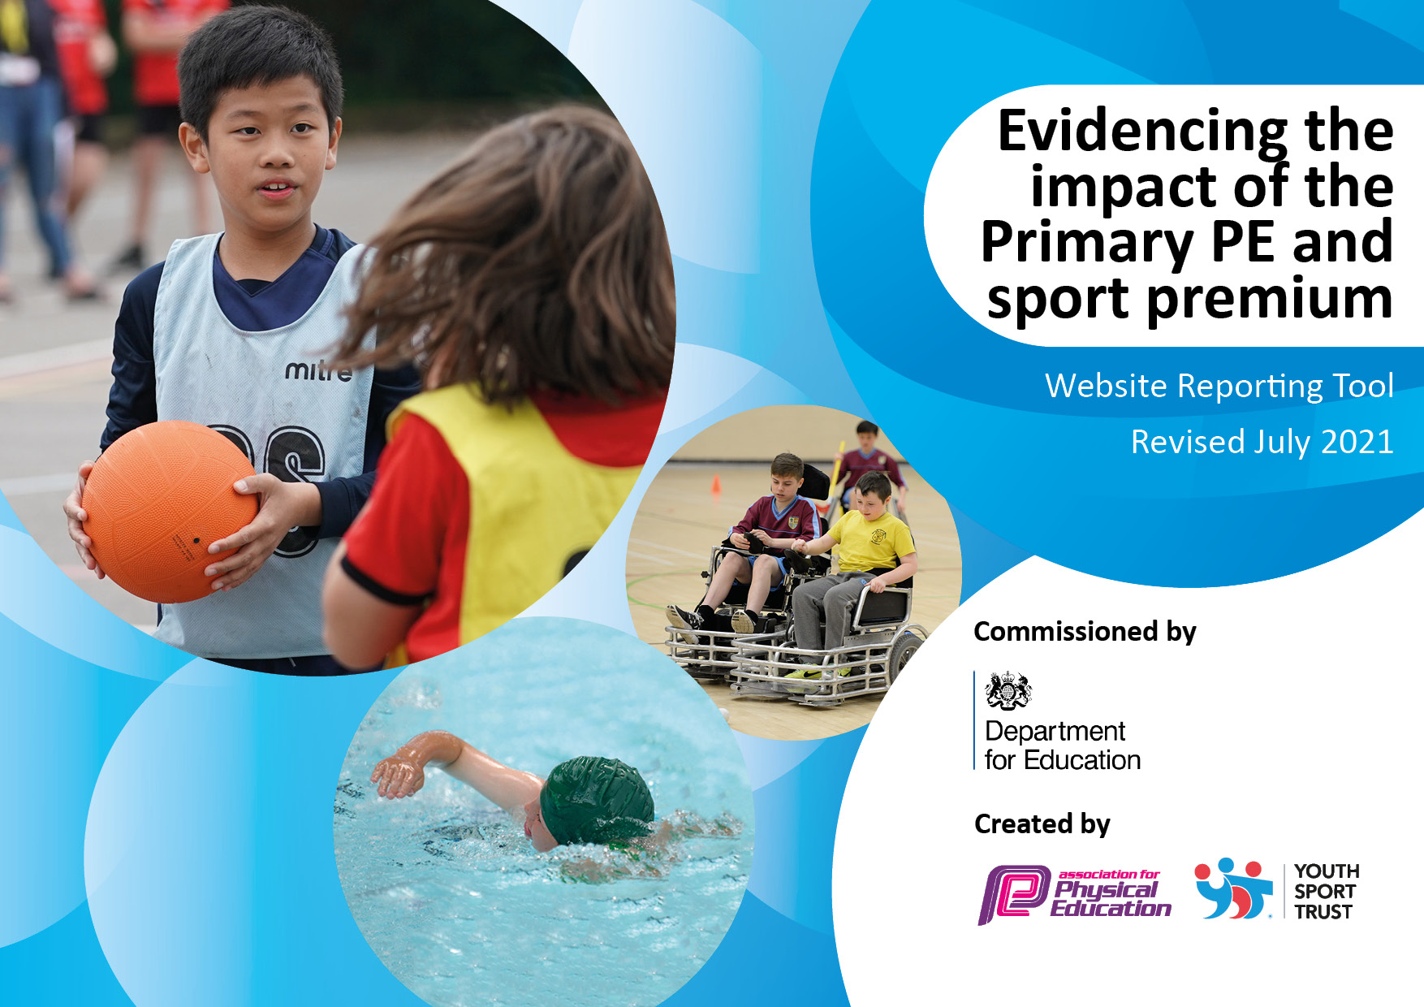
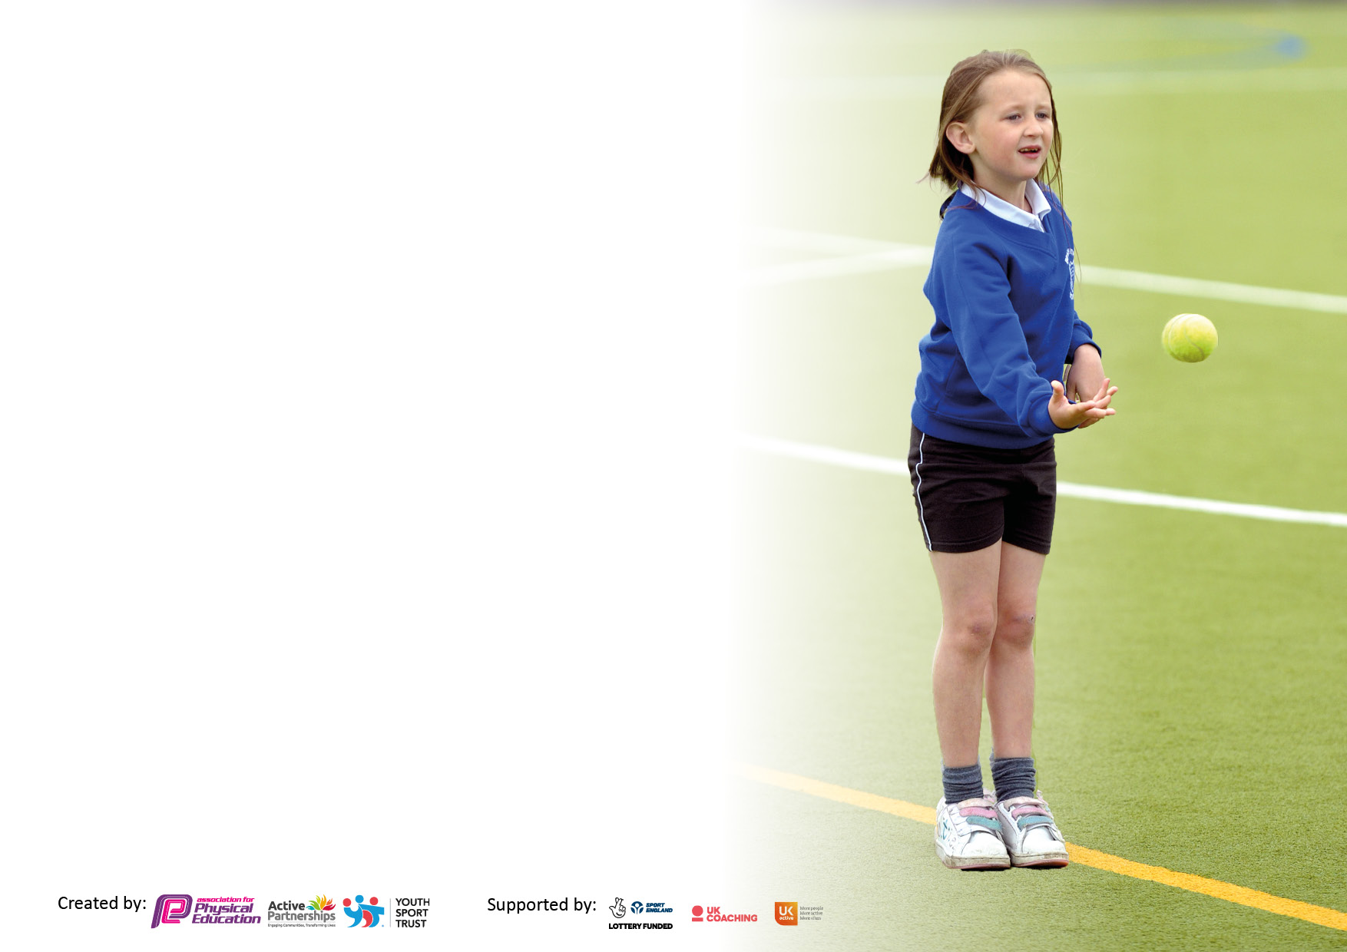

It is important that your grant is used effectively and based on school need. The Education Inspection Framework makes clear there will be a focus on ‘whether leaders and those responsible for governors all understand their respective roles and perform these in a way that enhances the effectiveness of the school’.

Under the Quality of Education Ofsted inspectors consider:
Intent - Curriculum design, coverage and appropriateness
Implementation - Curriculum delivery, Teaching (pedagogy) and Assessment
Impact - Attainment and progress

To assist schools with common transferable language this template has been developed to utilise the same three headings which should make your plans easily transferable between working documents.

Schools must use the funding to make additional and sustainable improvements to the quality of Physical Education, School Sport and Physical Activity (PESSPA) they offer. This means that you should use the Primary PE and sport premium to:

- Develop or add to the PESSPA activities that your school already offer
- Build capacity and capability within the school to ensure that improvements made now will benefit pupils joining the school in future years
- The Primary PE and sport premium should not be used to fund capital spend projects; the school’s budget should fund these.

Pleasevisitgov.ukfortherevisedDfEguidanceincludingthe5keyindicatorsacrosswhichschoolsshoulddemonstrate animprovement.Thisdocumentwillhelpyoutoreviewyourprovisionandtoreportyourspend.DfEencouragesschools to use this template as an effective way of meeting the reporting requirements of the Primary PE and sport premium.

We recommend you start by reflecting on the impact of current provision and reviewing the previous spend.

Schools are required to publish details of how they spend this funding, including any under-spend from 2019/2020, as well as on the impact it has on pupils’ PE and sport participation and attainment. All funding must be spent by 31st July 2022.

We recommend regularly updating the table and publishing it on your website throughout the year. This evidences your ongoing self-evaluation of how you are using the funding to secure maximum, sustainable impact. Final copy must be posted on your website by the end of the academic year and no later than the 31st July 2021. To see an example of how to complete the table please click HERE.

Details with regard to funding
Please complete the table below.

Total amount carried over from 2019/20 | £6359
Total amount allocated for 2020/21 | £18510
How much (if any) do you intend to carry over from this total fund into 2021/22? | 0
Total amount allocated for 2021/22 | £24869
Total amount of funding for 2021/22. To be spent and reported on by 31st July 2022. | £24841
Swimming Data
Please report on your Swimming Data below.

Meeting national curriculum requirements for swimming and water safety.

N.B. Complete this section to your best ability. For example you might have practised safe self-rescue techniques on dry land which you can then transfer to the pool when school swimming restarts.
Due to exceptional circumstances priority should be given to ensuring that pupils can perform safe self rescue even if they do not fully meet the first two requirements of the NC programme of study
What percentage of your current Year 6 cohort swim competently, confidently and proficiently over a distance of at least 25 metres?  N.B. Even though your pupils may swim in another year please report on their attainment on leaving primary school at the end of the summer term 2020.  Please see note above | 60%
What percentage of your current Year 6 cohort use a range of strokes effectively [for example, front crawl, backstroke and breaststroke]?  Please see note above | 59%
What percentage of your current Year 6 cohort perform safe self-rescue in different water-based situations? | 59%
Schools can choose to use the Primary PE and sport premium to provide additional provision for swimming but this must be for activity over and above the national curriculum requirements. Have you used it in this way? | Yes/No

Action Plan and Budget Tracking
Capture your intended annual spend against the 5 key indicators. Clarify the success criteria and evidence of impact that you intend to measure to evaluate for pupils today and for the future.

Academic Year: 2020/21 | Total fund allocated:18580 | Date Updated: January 2022
Key indicator 1: The engagement of all pupils in regular physical activity – Chief Medical Officers guidelines recommend that primary school pupils undertake at least 30 minutes of physical activity a day in school |  |  |  | Percentage of total allocation:
 |  |  |  | 14%
Intent | Implementation |  | Impact
Your school focus should be clear what you want the pupils to know and be able to do and about  what they need to learn and to  consolidate through practice: | Make sure your actions to achieve are linked to your intentions: | Funding allocated: | Evidence of impact: what do pupils now know and what can they now do? What has changed?: | Sustainability and suggested next steps:
Investment in new PE resources and equipment to supplement the Real PE scheme as well as outdoor PE planning: this will enable staff to deliver effective PE lessons both alongside Real PE scheme and outdoors including staff-run after school provision  Working towards at minimum 30 minutes of physical activity daily for all pupils, an outcome in the School Games Outcomes | Audit of current PE resources in line with Real PE long term plans;  Identification of resources required and purchase of these.  PE lead to assess activity levels throughout the day and use the Active Schools Planner Heatmap Tool | £3500 | Increase in physical abilities and fitness levels, teamwork, positive interactions between children in classes during lessons and also unstructured times such as playtimes and groups unsupported at lunch. Behaviour incidents have lowered.  Times of inactivity identified, least active children also identified including children requiring behaviour support. Pupil voice collected regards which sports they would like to play at lunch times and for after school clubs. | New resources purchased as and when need to replenish playtime equipment to ensure play times for all children are of high quality and provide high quality experiences of physical and mental wellbeing games at both structured and unstructured play times.  The least active children and children requiring the most support with behavioral issues with increase their physical activity and we will see a decline in unwanted behavior.
Key indicator 2: The profile of PESSPA being raised across the school as a tool for whole school improvement |  |  |  | Percentage of total allocation:
 |  |  |  | 41%
Intent | Implementation |  | Impact
Your school focus should be clear what you want the pupils to know and be able to do and about  what they need to learn and to  consolidate through practice: | Make sure your actions to achieve are linked to your intentions: | Funding allocated: | Evidence of impact: what do pupils now know and what can they now do? What has changed?: | Sustainability and suggested next steps:
After-school clubs – Covid compliant- DanceMania  Love Life Sports Coaching Years 2-6  Continued work with Bruce Dyer | A wide-range of after-school activities are provided to suit all ages and abilities.  Half termly lesson packages for classes Darwin upwards, pupils attitudes to sport and self-esteem continue to improve. | £4500  £5900 | Promotes active lifestyle and provides opportunities for children develop physical abilities and confidence in a range of sports;  Stimulate interest of children less likely to engage in sporting activities through use of different types of sports;  Develop extra-curricular provision of PE and sport. | Continue to Liaise with After school club providers and increase the number of clubs that Dancemania/Bruce Dyer provide to suit a wider age group of children and offer different skills sets to children.  Continue to listen to the voice of the pupils for input on activities they are more likely to engage in i.e. non competitive activities like running club or Zumba.

Key indicator 3: Increased confidence, knowledge and skills of all staff in teaching PE and sport |  |  |  | Percentage of total allocation:
 |  |  |  | 7%
Intent | Implementation |  | Impact
Your school focus should be clear | Make sure your actions to | Funding | Evidence of impact: what do | Sustainability and suggested
what you want the pupils to know | achieve are linked to your | allocated: | pupils now know and what | next steps:
and be able to do and about | intentions: |  | can they now do? What has
what they need to learn and to |  |  | changed?:
consolidate through practice:
All children to have access to a varied range of physical activities that encourage children to lead more active and healthy lives  Raise PE profile across school to impact whole school values  Continued use of Real PE to ensure high-quality Multi-Ability PE lessons in line with current curriculum requirements. Real Foundations introduction- specialised Early Years PE programme from Real PE  All teaching staff including HLTA to complete Real PE refresher training including assessment wheel training to baseline children’s physical development | Continue to implement and monitor Real PE Multi Ability scheme in at least 1 x hour lesson across the week.  Ensure PE is visible across school on displays and across social media platforms  Renewed Real PE subscription including ‘Real Foundations’ for Early Years Foundation Stage PE lessons  Pam Stevenson (Real PE) to attend a twilight session in September and drop in session for staff new to Real PE and Real Foundations | £571  £1250 | Equip children with high-quality PE equipment for their lessons; Purchased in July  Good or better PE lessons across school; Curriculum continues to be fully resourced and audited as well as replenished as needed. PE to be verbalized about and evident in and around school.  Classes to access one lesson per week of high quality indoor PE alongside Real PE- child centred approach Physical Education  Classes to access one half hour slot per week devoted to Gymnastics and use of large apparatus. Children showing much interest enthusiasm and confidence in using equipment. | All children (nursery to Year 6) to have a positive relationship with physical activity through the unique and child centred approach of Real PE
Key indicator 4: Broader experience of a range of sports and activities offered to all pupils |  |  |  | Percentage of total allocation:
 |  |  |  | 31%
Intent | Implementation |  | Impact
Your school focus should be clear | Make sure your actions to | Funding | Evidence of impact: what do | Sustainability and suggested
what you want the pupils to know | achieve are linked to your | allocated: | pupils now know and what | next steps:
and be able to do and about | intentions: |  | can they now do? What has
what they need to learn and to |  |  | changed?:
consolidate through practice:
Additional achievements:  Love Life Sports Coaching  Lunchtime Sport Opportunities for Summer Term  To provide children with an extra block of time for swimming in the local pool with instruction | Bruce Dyer to work on a daily rota’d timetable with each class on structured lunchtime activities.  All children offered extra block of swimming who missed out during the covid period. | £2580  £5040 | Develop children’s confidence and self esteem through trying a range of outdoor sporting activities. Develop the principles taught in lessons such as respect.  Date for upcoming years swimming abilities to gradually increase | Children showing an increase in confidence and targeted groups of children engaging in more physical activity. Behavioural issues declining and children showing more resilience and positivity.  Children to achieve the lifelong skill of swimming unaided and hold the ability to self rescue in any future situation.

Key indicator 5: Increased participation in competitive sport |  |  |  | Percentage of total allocation:
 |  |  |  | 7%
Intent | Implementation |  | Impact
Your school focus should be clear | Make sure your actions to | Funding | Evidence of impact: what do | Sustainability and suggested
what you want the pupils to know | achieve are linked to your | allocated: | pupils now know and what | next steps:
and be able to do and about | intentions: |  | can they now do? What has
what they need to learn and to |  |  | changed?:
consolidate through practice:
Children to partake and compete in Inter-school competitions, Intra- School competitions and Hub level tournaments. | Ensuring children have opportunity to take part in competitive sporting events: this will equip children with the opportunity to experience competitive sports, develop the sporting etiquette needed in these events and experience a range of venues. | £1500 | A range of children from across school participating in competitive sporting events. | Continue to provide transport to and from any event scheduled.  Continue to take part in Hub Inter House tournaments in 22/23  PE lead to continue to monitor the participation of PP, SEN, FSM groups regarding competitive sporting events ensuring fair access for all groups  Termly basis of liaising with other PE leads across the trust.

Signed off by
Head Teacher/  Vice Principal: | L.Sunley
Date: | 7.7.22
Subject Leader: | N. Hewitt
Date: | 01.07.22
Governor:
Date:

