Online resources for children and young people during the COVID-19 “stay at home” measures
You might be feeling overwhelmed, sad, or confused about the outbreak of coronavirus.
This is completely normal – things keep changing as we learn more about the virus, schools have closed, and people are now self-isolating to protect themselves and others.
This pack gives you information about some online resources that might help you through this time.

Children’s guide to coronavirus
The Children’s Commissioner has created a children’s guide to help answer your questions about coronavirus, tell you how to stay safe and protect other people and how to help you make the best of their time at home.
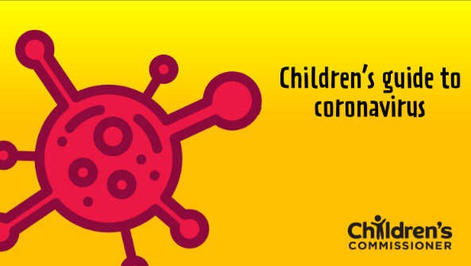

Coronavirus fact sheet for kids
A brief factsheet to help you understand what Coronavirus is, the importance of hand washing and how to help stop the virus spreading.
This was developed by the Alder Hey Children's NHS Foundation Trust.
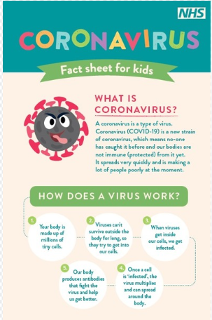

Coronavirus advice for young people under 25
Website “The Mix” gives lots of helpful advice and information on Coronavirus and health and wellbeing generally. There is also a 1-to-1 chat option and crisis line.

It’s important during this period of change and uncertainty that you remember to connect, be active and keep learning.
Connect with your feelings and emotions, with others and the world
Make the most of online opportunities during this time when we have to distance ourselves from others - but remember to do so safely.

Some resources to help you Connect -

Internet Matters in partnership with BBC
A wide range of resources and ideas to safely use the internet for learning, fun and communication by the whole family.

The Adventures of Kara Winston and the Smart Crew
Online Safety film and activities.

BBC Bitesize Fact or Fake
A set of resources to help question how reliable information shared online is. Includes myth busting about COVID-19.

Cove App – find this in the NHS App Library
Create music to capture your mood and express how you feel. Instead of words, create music to reflect emotions like joy, sadness, calm and anger. You can store your music in a personal journal or send them to someone and let the music do the talking.

Meetwo App
A safe and secure forum for teenagers to get advice from experts and peers.

Mindspace
Local website offering a range of emotional health and wellbeing resources.

Be Active
Children and young people aged 5 to 18 should aim for at least 60 minutes of moderate intensity physical activity every day. This is activity that makes you breathe faster and feel warmer. All the listed activities can be done at home. You can spread the activities throughout the day to do different things.

Some resources to help you Be Active-

Change4Life 10 minute shake ups
Change4Life and Disney have teamed up once again to bring you new 10 minute Shake Up games inspired by Disney and Pixar's Toy Story 4 and Incredibles 2, and Disney's The Lion King and Frozen.
Disney dance-a-longs
Earlier this year This Girl Can also partnered with Disney to create fun dance routines that you can follow, including The Jungle Book's 'I Wanna Be Like You', Moana's 'You're Welcome', The Little Mermaid and more.

Cosmic Kids Yoga
Yoga, mindfulness and relaxation designed especially for kids aged three or over. Used in schools and homes all over the world.
Nike - Active Kids Do Better
It can be great fun for families to get active together. Sometimes, even grown-ups need a bit of support. Check out Nike's Active Home family-friendly activities.
Accessible activities for kids
There are lots of ways that you can keep active if you have a disability. Start off by choosing activities you’re interested in and adapt them. (Please note, not all of these activities are recommended during this time of physical distancing).
Jump Start Jonny
Fun workout videos to get kids moving, age 5-11.

BBC Super Movers
Fun curriculum-linked resources for 9-11 year olds, to get you moving while you learn.
Premier League Primary Stars
Activities to help 5-11 year olds develop skills in everything from balance and coordination to athletics and throwing.

Go Noodle Movement and Mindfulness videos
Videos created by child development experts
Go Noodle Games app
Use your actions to control a load of fun movement mini-games designed to wake up your bodies, engage your minds, and let you have tons of fun
Oti Mabuse dance classes
Great dance sessions from one of the stars of Strictly Come Dancing.

PE with Joe Wicks
At 9am every weekday for 30 minutes live on YouTube. No special equipment needed.

Keep Learning
It’s really important that you can continue to learn while schools and colleges are closed.

Some resources to help you Keep Learning –
Premier League Primary Stars worksheets
Fun videos, games and worksheets for 5-11 year olds in Maths, English and Health and Wellbeing.

Hit the Button
Online maths learning games for 6-11 year olds.

Audible stories
For as long as schools are closed, Audible are making many stories free to listen to. They include children’s books and literary classics. Free to stream on desktop, laptop, phone or tablet.

Histrionics
Free history videos for home learning, schools, families and history fans. Available on YouTube and Facebook:
YouTube Channel: Histrionics Entertainment
Facebook: @allthehistory

South Yorkshire Safer Roads
Downloadable colouring sheets to help learn about the Green Cross Code.

STEM Learning: activities to do at home
A range of fun, hands-on activities for families to use at home. Suitable for ages 4 – 16years.

BBC Bitesize
Daily content to help you learn and revise. Includes Primary, Secondary and Post-16.

Rise Above
You’ll find inspiring and useful stories, videos, games and advice linked to Personal Social and Health Education.

Finally, although the Public Health Nursing Service (0-19) are having to reduce face-to-face contact during this time, they are still offering support in different ways.
School Nurses are still providing support and advice to children and young people and
The Services Facebook page is updated regularly.

Anyone who has concerns about a child or young person can contact the Service by-

Telephone: 01226 77 44 11
Lines open Monday to Thursday 8.45am to 4.45pm and Friday 8.45am to 4.15pm

E-mail: 0-19healthteam@barnsley.gov.uk
In writing: 0-19 Public Health Nursing Service, PO Box 634, Barnsley S70 9GG

