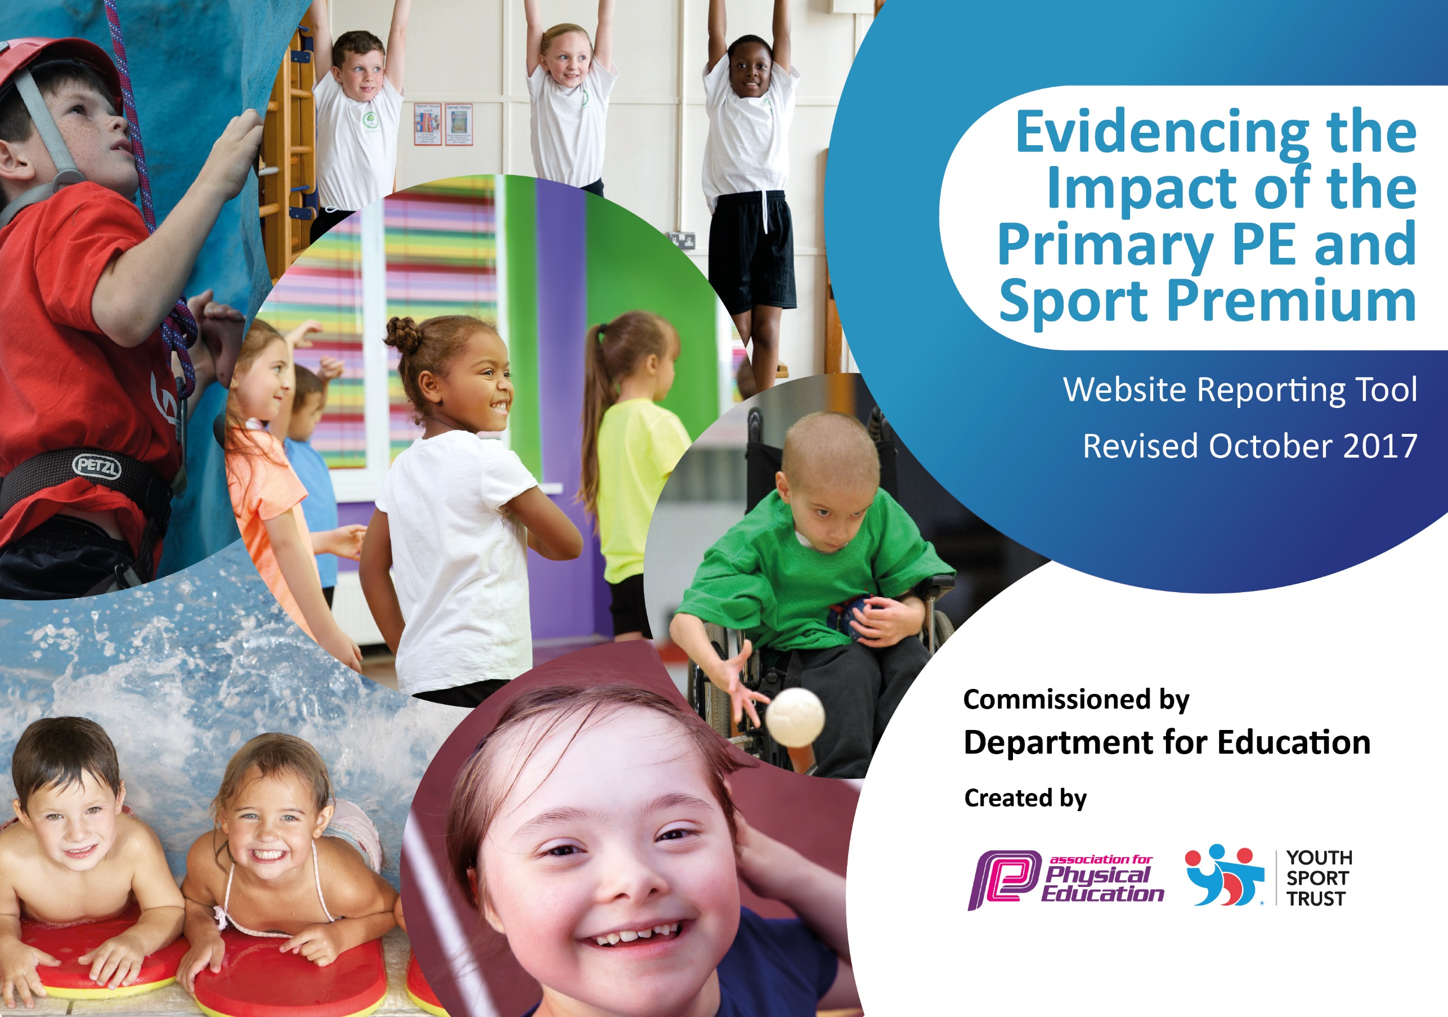

Schools must use the funding to make additional and sustainable improvements to the quality of PE and sport they offer. This means that you should use the Primary PE and Sport Premium to:

- develop or add to the PE and sport activities that your school already offers
- build capacity and capability within the school to ensure that improvements made now will benefit pupils joining the school in future years

Please visit gov.uk for the revised DfE guidance including the 5 key indicators across which schools should demonstrate an improvement. This document will help you to review your provision and to report your spend. DfE encourages schools to use this template as an effective way of meeting the reporting requirements of the Primary PE and Sport Premium.

We recommend you start by reflecting on the impact of current provision and reviewing the previous spend.
Under the Ofsted Schools Inspection Framework, inspectors will assess how effectively leaders use
the Primary PE and Sport Premium and measure its impact on outcomes for pupils, and how effectively governors hold them to account
for this.

Schools are required to publish details of how they spend this funding as well as on the impact it has on pupils’ PE
and sport participation and attainment.
We recommend regularly updating the table and
publishing it on your website as evidence
of your ongoing review into how you are using the money
to secure maximum, sustainable impact. To see an example of how to complete the table please click HERE.

Support for review and reflection - considering the 5 key indicators from DfE, what development needs are a priority for your setting and your students now and why? Use the space below to reflect on previous spend, identify current need and priorities for the future.

Key achievements to date: | Areas for further improvement and baseline evidence of need:
70% of pupils taking part in an after school club  Interschool competition  Running club with parental participation | Equipment and resources, including storage  New Curriculum documents to be purchased, including assessment  Achieve at least Bronze level on School Games Mark

Meeting national curriculum requirements for swimming and water safety | Please complete all of the below:
What percentage of your Year 6 pupils could swim competently, confidently and proficiently over a distance of at least 25 metres when they left your primary school at the end of last academic year? | Began swimming with Y3 in 2016/17 63% achieved 25m standard
What percentage of your Year 6 pupils could use a range of strokes effectively [for example, front crawl, backstroke and breaststroke] when they left your primary school at the end of last academic year? | Began swimming with Y3 in 2016/17 63% could use a range of strokes effectively
What percentage of your Year 6 pupils could perform safe self-rescue in different water-based situations when they left your primary school at the end of last academic year? | Began swimming with Y3 in 2016/17 63% could self-rescue
Schools can choose to use the Primary PE and Sport Premium to provide additional provision for swimming but this must be for activity over and above the national curriculum requirements. Have you used it in this way? | Yes/No

Action Plan and Budget Tracking
Capture your intended annual spend against the 5 key indicators. Clarify the success criteria and evidence of impact that you intend to measure to evaluate for students today and for the future.

Academic Year: 2017/18 | Total fund allocated: £18520 | Date Updated: February 2018
Key indicator 1: The engagement of all pupils in regular physical activity – Chief Medical Officer guidelines recommend that primary school children undertake at least 30 minutes of physical activity a day in school |  |  |  | Percentage of total allocation:
 |  |  |  | 50%
School focus with clarity on intended impact on pupils: | Actions to achieve: | Funding allocated: | Evidence and impact: | Sustainability and suggested next steps:
Resources- investment in new resources to supplement new LCP planning so that staff can effectively deliver PE lessons.  After school clubs – Ensure a wide variety of after school clubs are available to suit all ages and abilities  Totally Runable – Develop attitudes and improve self- esteem particularly UKS2 girls  PE resources and storage – To support CPD and keep PE, sport and playtime equipment to be stored centrally in an orderly way inside the school grounds. | -PE lead to sort through all existing resources – Day release  -PE lead to audit resources and purchase new resources before the beginning of each new half term topic.  -PE lead to liaise with Team Activ, Astrea Active, Dance teachers, football coaches and other professionals to provide an enriched programme of opportunities.  -PE lead and teachers to identify a suitable age group to take part in the course  -PE lead to book and liaise with  Totally Runable.  -Head teacher to source and purchase a large, secure storage container and shelving units.  -PE lead to organize and label all the resources clearly. | £1000  £3600  £1500  £3000 | -Equip children with the best possible equipment for activities.  -Curriculum is fully resourced and audited.  -Continue to replenish as and when required.  -Promote activity and provide opportunities for children to be active and build confidence in a variety of sports  -Stimulate interests of children less likely to engage in sport ~(i.e. Quiddich)  -Develop extra-curricular provision of PE and sporting activities.  -Develop pupil confidence,  collaboration and self-esteem through outdoor activities.  -A place for school to properly store equipment to ensure it is kept well and therefore lasts longer, in better condition
Key indicator 2: The profile of PE and sport being raised across the school as a tool for whole school improvement |  |  |  | Percentage of total allocation:
 |  |  |  | 2%
School focus with clarity on intended impact on pupils: | Actions to achieve: | Funding allocated: | Evidence and impact: | Sustainability and suggested next steps:
Staff PE kit – Raise awareness of the importance of correct and suitable clothing when undertaking excercise  Termly assembly to raise profile of sport and celebrate achievements and attitudes towards sport and exercise in and out of school. | -Head teacher/PE lead to source a company for staff hoodies/sweatshirt with school logo to raise profile  -PE lead to organize an assembly at the end of each term to celebrate pupils’ achievements | £300  £150 | -A chance for staff to model good practice and see an increase in the number of pupils remembering kit for PE  -Chance for children to share achievements from outside school i.e. horse riding, hockey, rugby etc. Sparks interest from other pupils  -Recognition for efforts in PE lessons

Key indicator 3: Increased confidence, knowledge and skills of all staff in teaching PE and sport |  |  |  |  | Percentage of total allocation:
 |  |  |  |  | 8%
School focus with clarity on ntended  impact on pupils: | Actions to achieve: | Funding  allocated: |  | Evidence and impact: | Sustainability and suggested  next steps:
Development of PE lead to build on subject knowledge and share best practise from other leads across and beyond the trust  New curriculum planning to ensure curriculum coverage  -Planning will support teachers to build on the relevant skills needed to play and take part in sports both competitive and non-competitive. | -PE lead to be released for termly Astrea Active conferences  -Meet with Team Active to arrange CPD to upskill teachers and arrange events  - Host interhouse competitions  -Develop skills of the leader to  evaluate impact of PE provision.  -PE lead to research and buy new planning | £700  £750 |  | Sport survey  Astrea active conference  Hub meetings  Liaise with other sports people involved with school  Purchased LCP planning for new 2014 curriculum  Copies in shared along with a LTP to advise teachers which unit to teach.
Key indicator 4: Broader experience of a range of sports and activities offered to all pupils |  |  |  |  | Percentage of total allocation:
 |  |  |  |  | 44%
School focus with clarity on intended  impact on pupils: | Actions to achieve: | Funding  allocated: |  | Evidence and impact: | Sustainability and suggested  next steps:
Additional achievements:  P.E. Coach | High quality provision in school to ensure legacy of teaching skills | £8100 |  | Monitoring & Evaluation
Key indicator 5: Increased participation in competitive sport |  |  |  |  | Percentage of total allocation:
 |  |  |  |  | 8%
School focus with clarity on intended  impact on pupils: | Actions to achieve: |  | Funding  allocated: | Evidence and impact: | Sustainability and suggested  next steps:
Inter school competitions to introduce children to the competitive side of sports and the etiquette which comes with it. | -PE lead to monitor participation in football and mutli-skill activities.  -Widen opportunities across the Dearne hub in 17/18 (once per half term)  -Continue to use venues such as EIS to broaden children’s outlook on sport and physical activity. |  | £1500 | Football tournament at Barnsley Football ground (Dec 2017)  Totty cup  Intra-house tournaments  Inter-house tournaments – half termly  Quiddich tournament – Hosted by Team Activ

Total Number of Pupils on Roll | 316
Amount of Sport Premium Received | £118250
Total Planned Spend | £20600

